CCPA Validation :

DEFECT 81- New file needs to be processed. Processed the New file.

DEFECT 70- Employee training scope needs to added.

‘Employee Scope’ Attribute has been added to the detail section and is available in all chapters.

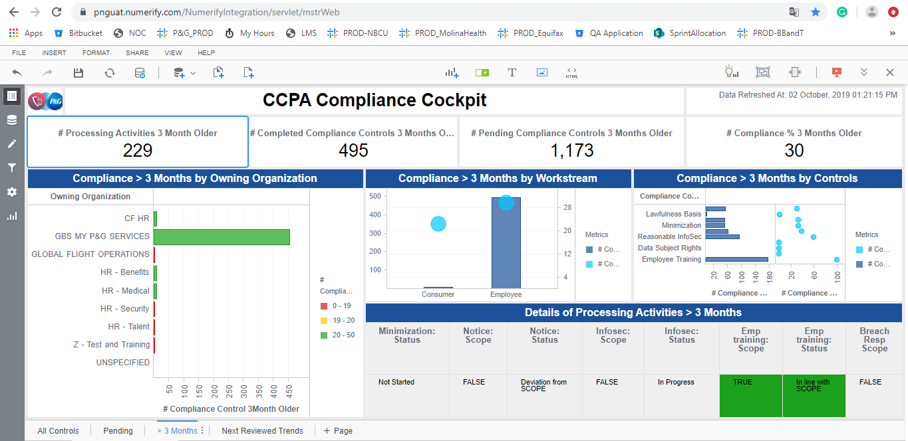

DEFECT 80- Ideally a CR - Please remove filter on Details Visual that is excluding RoPAs having no compliance controls in scope or no pending compliance controls. Both filters to be excluded.    
 This changes will be included as it is only a visualization change.

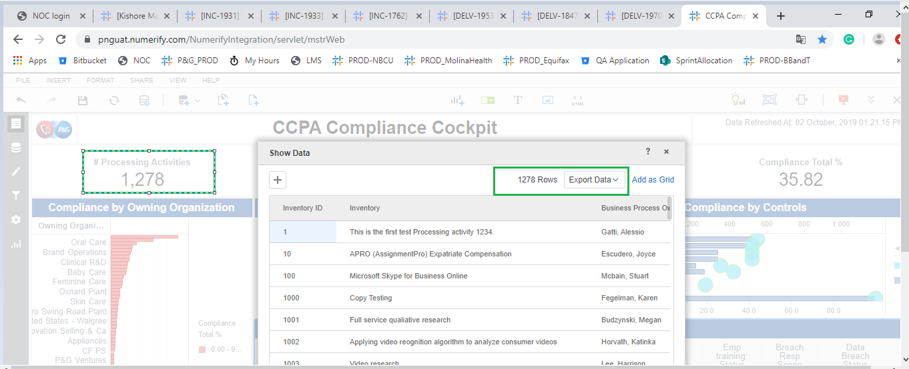

Removed the Filter :

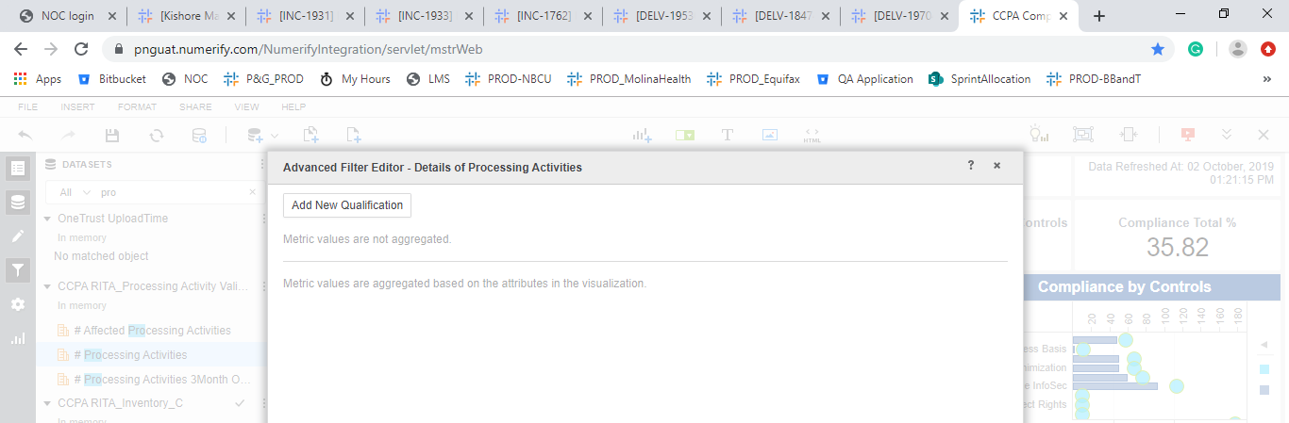

           DEFECT 66- CCPA compliance cockpit - RoPA which are less than 3 months old appear in tab ">3 months old"

* Months is working fine, post processing the file on 03-Oct-2019

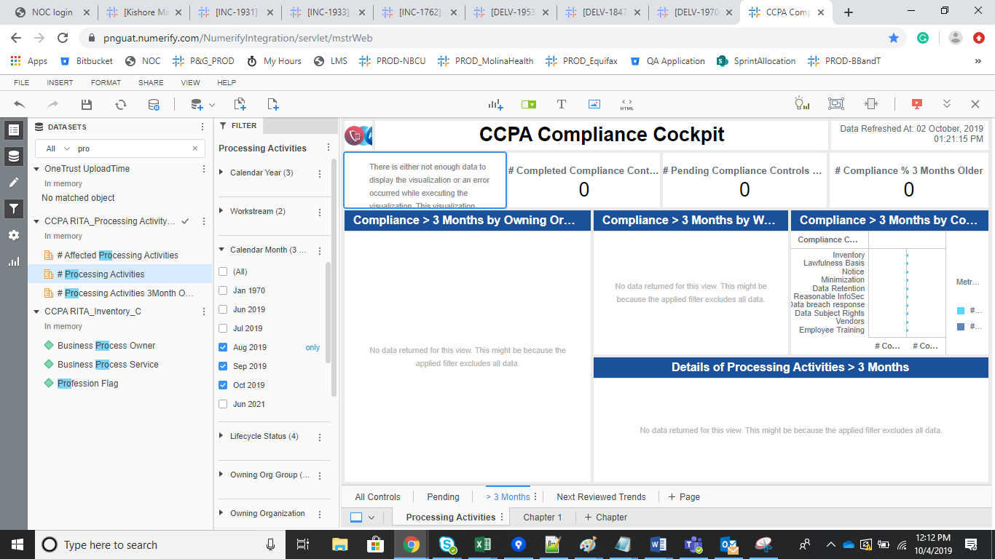

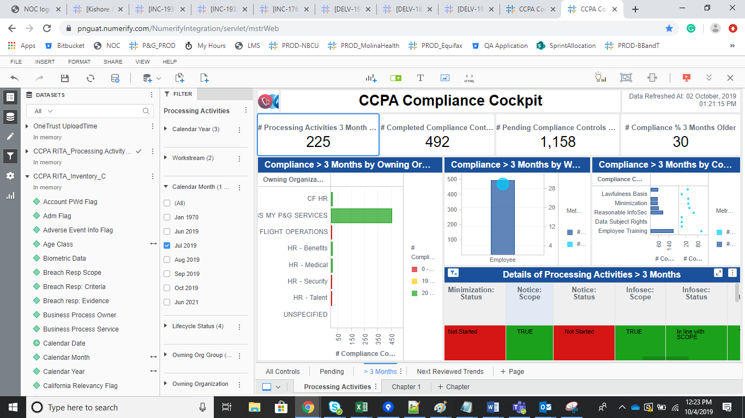

DEFECT 79- CCPA: Compliance Control selected by default (and invisible) in "Compliance by Control" Visual

